**Saint Victoria Catholic Church**

A Roman Catholic Community

PO Box 640

305 Victoria Drive

Hurt, VA 24563-0640

Phone: 434-324-4824

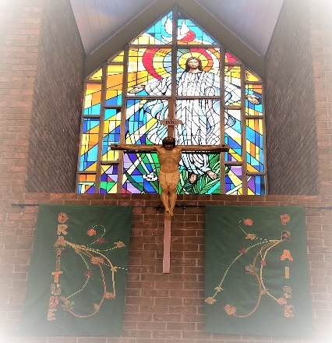

Brothers and Sisters,

One of the goals of the Jubilee Year is celebrating reconciliation.  That means asking for forgiveness from those we have harmed in any way but to also grant forgiveness to those who have offended you and me.

"Making amends" is something which transcends forgiveness. Not only that we have expressed sorrow, but we go about setting things in right relationship by doing good. In other words, we build back better! Although we might not be struggling with addiction or a bad habit we can use Step 9 of the 12 Step Program. That is a "call to work with those we have harmed" by sin.

Direct amends means that we help to heal directly those we have hurt. Indirect amends means that we help to heal our world in general. Making either one of these kind amends is a form of penance and helps to alleviate shame.

This Lent I hope to float the idea for amends for our liturgy committees in both parishes. There will be examples at Mass each week. Pay attention!

Also, we have people preparing for sacraments from both parishes. One of my favorite sayings is, "Sacraments build the community and the community builds the sacraments.” So Community, please write and pray for those preparing. An encouraging greeting card would be helpful

Remember to bring in your food items for St. Phoebe Food Pantry at St. Victoria and Mac's Kitchen at Our Lady of Peace. You enhance the reality that Jesus is the Bread of Life.

Might that the Lord continue the good work He is already doing as you heed your Baptismal call to be priest, prophet and builder of the reign of God.

In Christ's peace,

Fr. Jim Gallagher