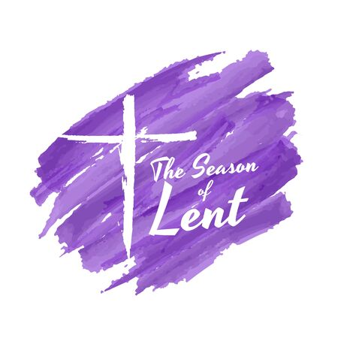

**2025 *LENTEN* Calendar**

**OCIA (RCIA) Candidates: Clayton Jungling, Laura Johnson and Kevin Johnson (STV)**

**High School Confirmation Candidates: Beatrice Heady and Itzell Valesco (OLP)**

**Charles Butt and Sierra Bartalotta (STV)**

**Stations of the Cross – Every Friday @ 6:00pm (STV) & (OLP)**

Monday, March 3 – Shrove Monday, Pancake Dinner @ 5:30pm; Prayer & Burning of Palms @ 7:00pm **(STV)**

Tuesday, March 4 – Shrove Tuesday – Evening Prayer and Burning of Palms **(OLP)**

Wednesday, March 5 – Ash Wednesday,

10:00am Mass/Ashes and 7:00pm Evening Prayer/Ashes **(STV)**

12:30pm Mass/Ashes and 7:00pm Evening Prayer/Ashes **(OLP)**

Sunday, March 9 – 1st Sunday of Lent, Special Rites for Clayton, Laura and Kevin **(STV**)

and Beatrice and Itzell **(OLP)**

Sunday, March 16 - 2nd Sunday of Lent

Sunday, March 23 – 3rd Sunday of Lent

Wednesday, March 26 – Reconciliation/Confession for Children **(OLP)**

Saturday, March 29 – Reconciliation/Confession for ALL @ 10:30am **(OLP)**

Sunday, March 30 – 4th Sunday of Lent - – Anointing of the Sick (STV) and **(OLP)**

Thursday, April 3 - Confessions/Reconciliation @ 6:30pm **(STV**)

Sunday, April 6– 5th Sunday of Lent

Wednesday, April 9 – Confirmation at St. Thomas More for Beatrice Heady & Itzell Valesco

Sunday, April 13 – PALM SUNDAY

Monday, April 14 – Set up for Holy Thursday after 10:00am Mass **(STV)**

Chrism Mass at the Cathedral @ 6:00pm, Father picks up new oils

Tuesday, April 15 – Set up for Holy Thursday **(OLP)**

Wednesday, April 16 – Rehearse for Triduum 11:00am **(STV)**; 5:00pm **(OLP)**

Thursday, April 17 – Holy Thursday **(OLP)**

**Saint Victoria (STV)**

**Our Lady of Pease (OLP)**